API Overview & Reference
Star Wars API (SWAPI) - People Resource

Introduction
The Star Wars API, also known as SWAPI, enables programmers to interact with data in the Star Wars universe. This document describes characters in the Star Wars story. Developers use SWAPI to get all kinds of details regarding characters in the Star Wars universe, their personal details, their relationships with other characters, and how they appeared in movies.
People Resource
"Person" resource defines a single individual or character belonging to the Star Wars universe. Information about a person includes details of his biography, like body characteristics, date of birth, origin planet, etc., as well as movies in which he appeared.
This resource also keeps connections to other API resources like planets, species, starships, and vehicles.
Use Case
You can use this API to:
- Build Star Wars character dashboards
- Create search/filter applications
- Integrate character data into games or fan apps
- Perform data analysis on fictional datasets

Getting Started
You can make HTTP requests directly to the API endpoints without authentication. The base URL for all requests is https://swapi.py4e.com/api/.
- Use Simple GET requests to retrieve data.
- API returns in JSON format.
Basic Workflow

System Requirements
- Access to the internet and a browser or HTTP client (such as Postman, curl, or httpie)

Authentication
The SWAPI is completely open and requires no authentication.

Pricing
SWAPI offers free access. You need no subscription, credits, or payment to access the data.

Rate Limiting
To prevent malicious abuse and ensure service stability, SWAPI enforces rate limiting on a per-IP-address basis. The system limits you to 10,000 API requests per day per IP address. Additionally, SWAPI applies rate-slowing after the 5th request within a 15-minute window and delays each request by 100ms to encourage reasonable usage patterns.
Example: If I make 6 requests within 15 minutes, the 6th request is delayed by 100ms, the 7th by 200ms, and so on.

Return Status Codes
The API responds with standard HTTP status codes. Understand these codes to handle the responses appropriately.
HTTP Status Code | Status | Response Body | Description
200 | OK | Empty or success message | Retrieved character data successfully.
400 | Bad Request | Error message | Invalid character ID supplied.
404 | Not Found | Error message | Character not found in the database.

// Example 400 Bad Request Response
{
"detail": "Invalid request parameters"
}
// Example 404 Not Found Response
{
"detail": "Not found"
}

API Reference - People Resource

Get All People

Resource
/people

Introduction
This API gives detailed information about the characters within the Star Wars universe.

HTTP Method
GET

Base URL

swapi.py4e.com/api/

End Point
/people

cURL
https://swapi.py4e.com/api/people

Request URL

https://swapi.py4e.com/api/people

Example URL

https://swapi.py4e.com/api/people

Request Parameters
Parameters | Required/Optional | Data Type | Values | Description
page  people | Optional | Int64 | Positive Integer | Page number for pagination. Default is page 1.

Response Parameters
Parameters | Child parameters | Data type | Values | Description
count |  | Int64 |  | The total number of character resources (82).
next |  | String |  | URL of next page results.
previous |  | Null |  | URL of previous page.
results | name | Array |  | The full name of the character.
 | height | string |  | Height of the character in centimeters.
 | mass | string |  | Weight of the character in kilograms.
 | hair_color | string | This will be “unknown” if the color is not known and “n/a” if the person does not have hair. | Hair color of the character.
 | skin_color | String |  | Skin color of the character
 | eye_color | String | This will be “unknown” if not known or “n/a” if the person does not have an eye. | Eye color of the character.
 | birth_year | String |  | Birth year of the person in the Star Wars chronology (BBY = Before the Battle of Yavin, ABY = After the Battle of Yavin).
 | gender | String | This will be “unknown” if not known or “n/a” if the person does not have an eye. | Gender of the character.
 | homeworld | String |  | A URL link to the character’s home world resource where the character is born or resides.
 | films | array |  | An array of URLs for films in which the character appeared.
 | species | Array |  | An array of URLs for the species to which the character belongs.
 | starships | Array |  | An array of URLs of all the starships captained by the character.
 | vehicles | Array |  | An array of URLs for vehicles operated by the character.
 | url | String |  | The hyperlink URL of the resource.
 | created | String |  | ISO 8601 timestamp indicating when this resource was created in the database.
 | edited | string |  | ISO 8601 timestamp indicating when this resource was last updated in the database.

Sample JSON Response
{
"count": 82,
"next": "https://swapi.dev/api/people/?page=2",
"previous": null,
"results": [
{
"name": "Luke Skywalker",
"height": "172",
"mass": "77",
"hair_color": "blond",
"skin_color": "fair",
"eye_color": "blue",
"birth_year": "19BBY",
"gender": "male",
"homeworld": "https://swapi.dev/api/planets/1/",
"films": [
"https://swapi.dev/api/films/1/",
"https://swapi.dev/api/films/2/",
"https://swapi.dev/api/films/3/",
"https://swapi.dev/api/films/6/"
],
"species": [],
"vehicles": [
"https://swapi.dev/api/vehicles/14/",
"https://swapi.dev/api/vehicles/30/"
],
"starships": [
"https://swapi.dev/api/starships/12/",
"https://swapi.dev/api/starships/22/"
],
"created": "2014-12-09T13:50:51.644000Z",
"edited": "2014-12-20T21:17:56.891000Z",
"url": "https://swapi.dev/api/people/1/"
},
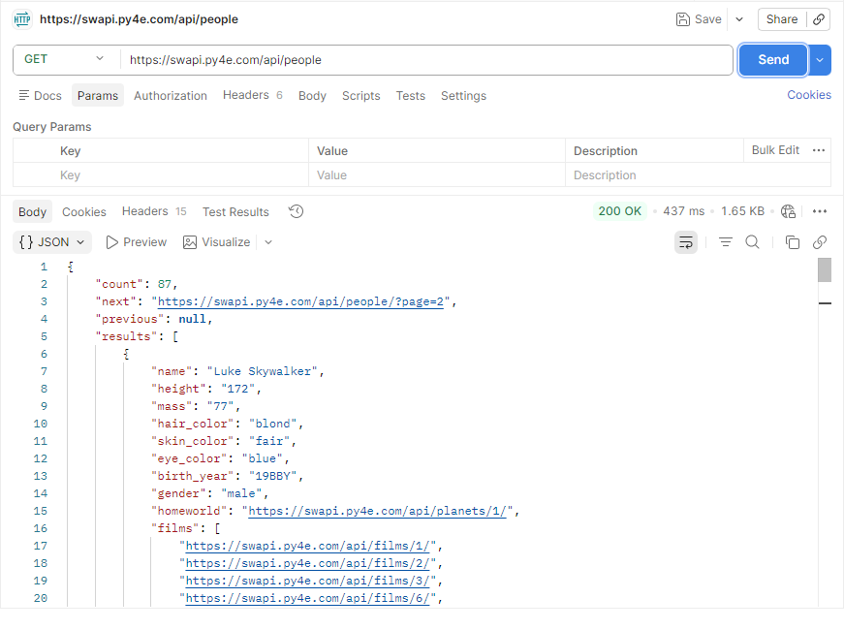

Get a Specific Person

Resource
/people/

Introduction
This API gives detailed information about a person or character within the Star Wars universe.

HTTP Method
GET

Base URL

swapi.py4e.com/api/

End Point
/people/{id}

cURL
https://swapi.py4e.com/api/people/77

Request URL

https://swapi.py4e.com/api/people/{id}

Example URL
https://swapi.py4e.com/api/people/77

Request Parameters
Parameters | Required/Optional | Data Type | Values | Description
id | Required | Int64 | Positive Integer | The unique numeric identifier for the character (e.g., 77 for San Hill).

Response Parameters

Parameters | Data Type | Values | Description
name | string |  | The full name of the character.
height | string |  | Height of the character in centimeters.
mass | string |  | Weight of the character in kilograms.
hair_color | string |  | Hair color of the character. This will be “unknown” if the color is not known and “n/a” if the person does not have hair.
Skin_color | string |  | Skin color of the character
eye_color | string | This will be “unknown” if not known or “n/a” if the person does not have an eye. | Eye color of the character.
birth_year | string |  | Birth year of the person in the Star Wars chronology (BBY = Before the Battle of Yavin, ABY = After the Battle of Yavin).
gender | string | Either “Male”, “Female”, “unknown”, or “n/a” if the person does not have a gender. | Gender of the character.
homeworld | string |  | A URL link to the character’s home world resource, where the character is born or resides.
films | array |  | An array of URLs for films in which the character appeared.
species | array |  | An array of URLs for the species to which the character belongs.
starships | array |  | An array of URLs of all the starships captained by the character.
vehicles | array |  | An array of URLs for vehicles operated by the character.
url | string |  | The hyperlink URL of the resource.
created | string |  | ISO 8601 timestamp indicating when this resource was created in the database.
edited | string |  | ISO 8601 timestamp indicating when this resource was last updated in the database.

Sample JSON Response
Example: San Hill (ID:77)
{
"name": "San Hill",
"height": "191",
"mass": "unknown",
"hair_color": "none",
"skin_color": "grey",
"eye_color": "gold",
"birth_year": "unknown",
"gender": "male",
"homeworld": "https://swapi.dev/api/planets/57/",
"films": [
"https://swapi.dev/api/films/5/"
],
"species": [
"https://swapi.dev/api/species/34/"
],
"vehicles": [],
"starships": [],
"created": "2014-12-20T17:58:17.049000Z",
"edited": "2014-12-20T21:17:50.484000Z",
"url": "https://swapi.dev/api/people/77/"
}

